FILTER OPERATIONS

1️⃣ Find Unexpected Audience Hits
(Poor critic ratings but high audience scores)

db.movies.find({
$and: [
{ "metacritic": { $lt: 50 } },
{ "imdb.rating": { $gt: 7.5 } }
]
})

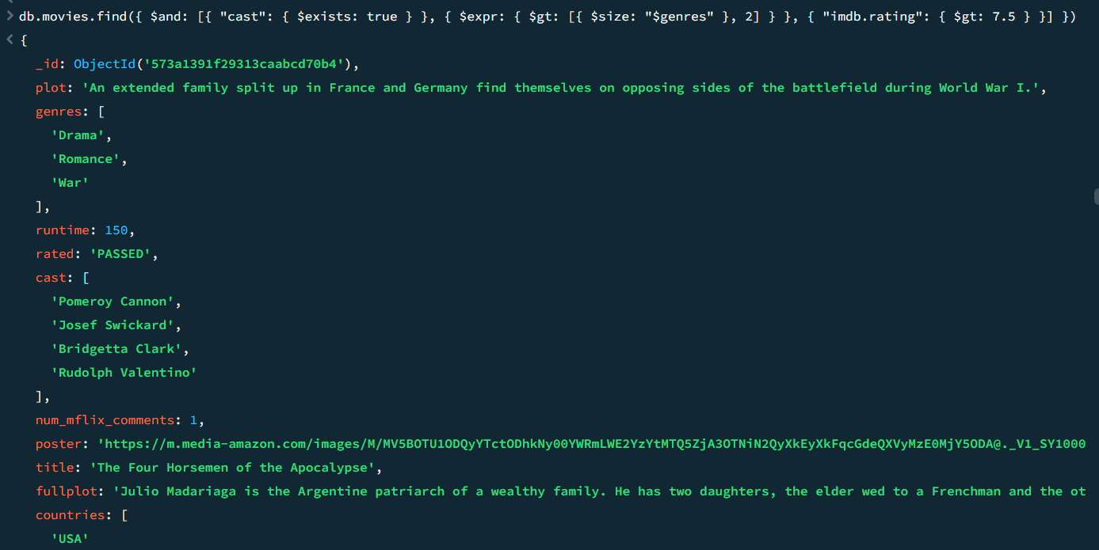



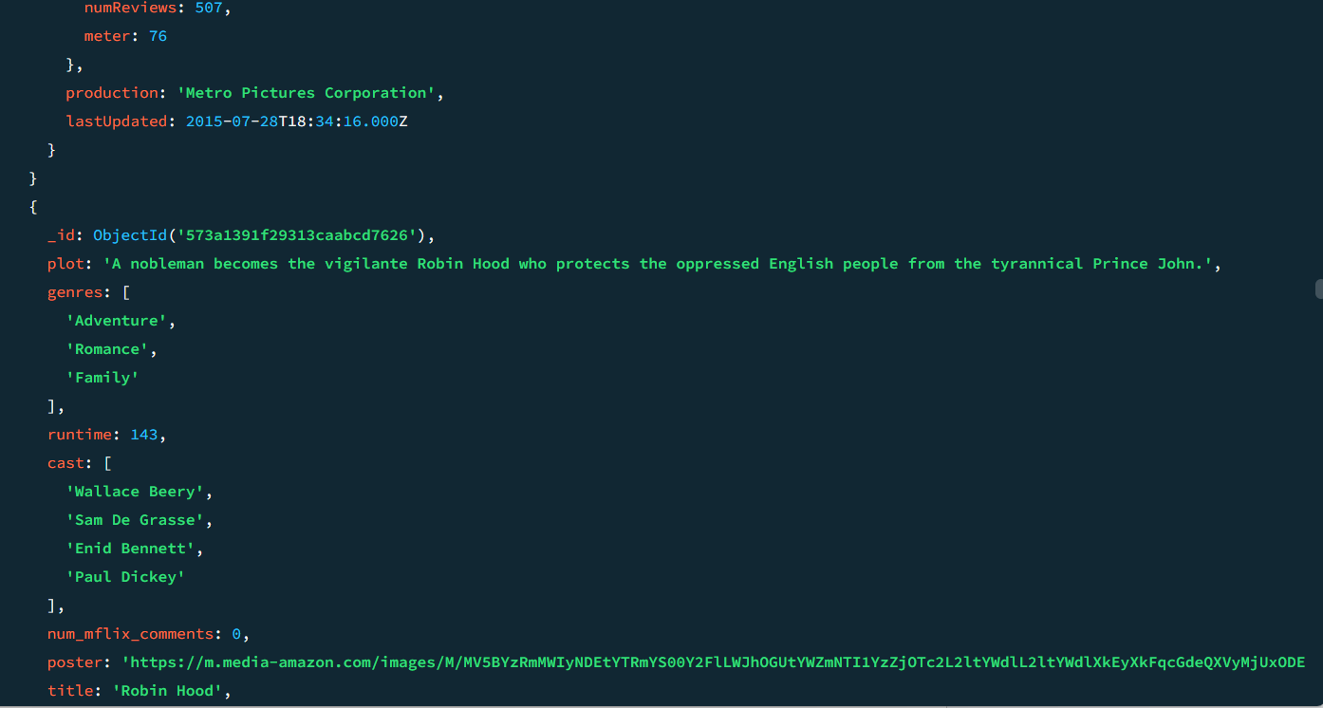

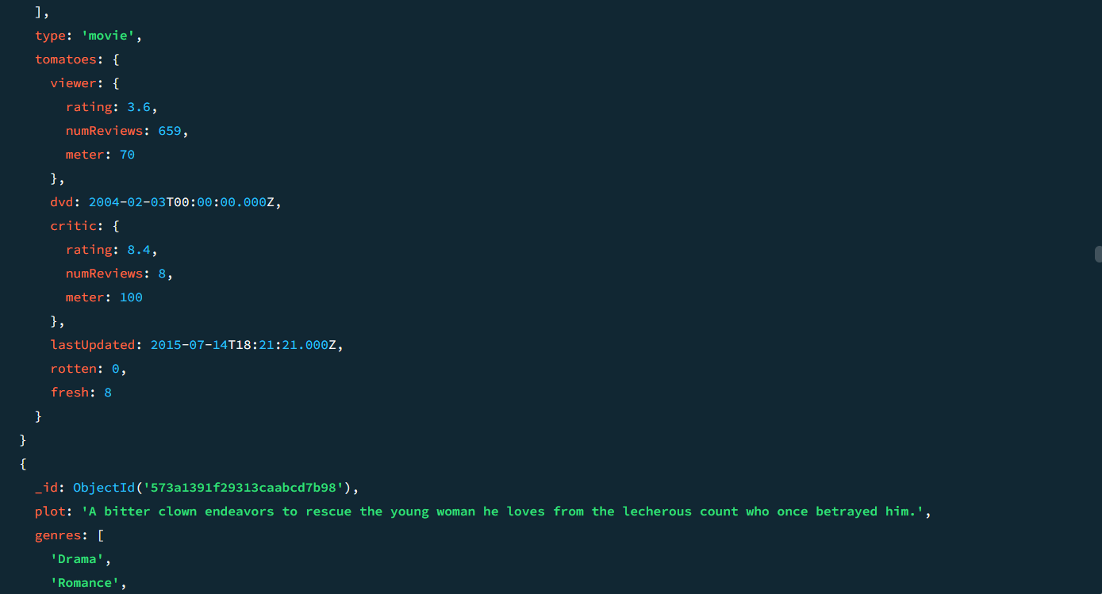

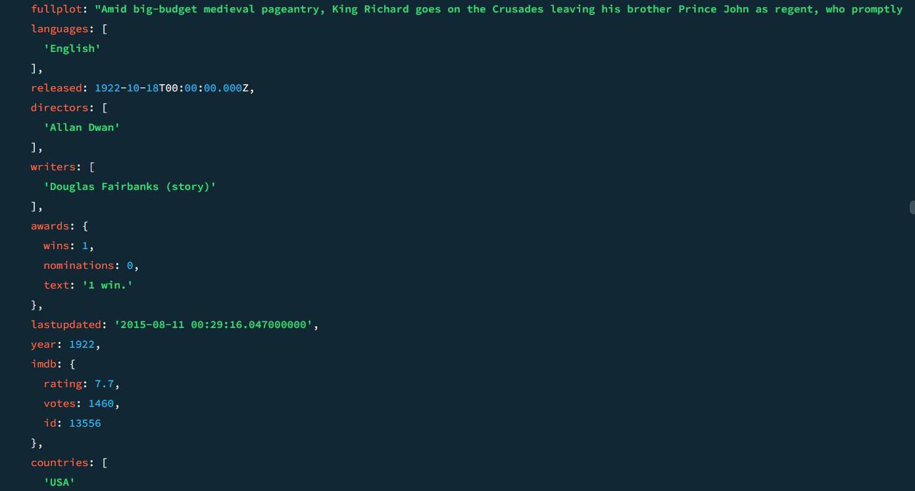

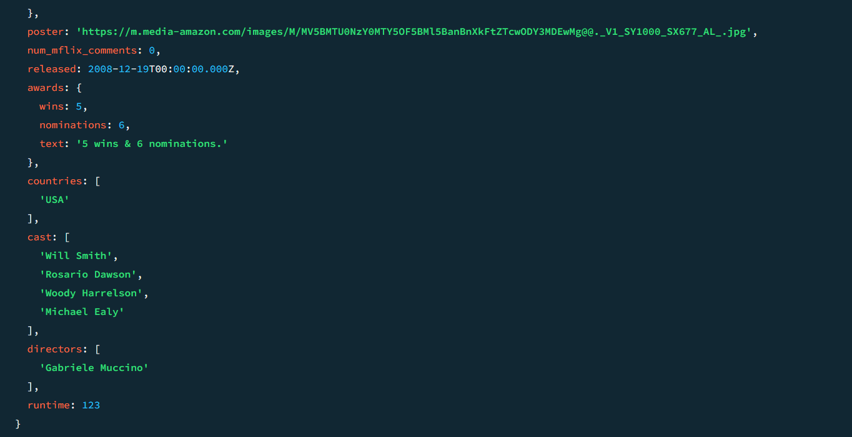

2️⃣ Find Potentially Undervalued International Content
(High-rated but low-vote non-USA films)

db.movies.find({
$and: [
{ "countries": { $ne: "USA" } },
{ "imdb.rating": { $gt: 7.5 } },
{ "imdb.votes": { $lt: 25000 } }
]
})

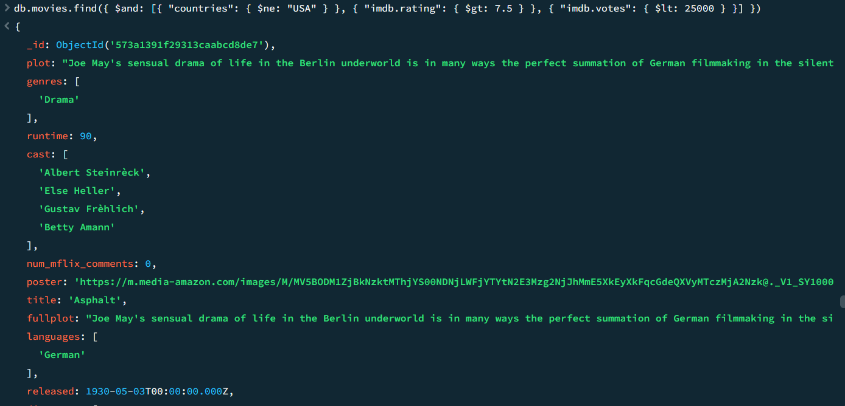



3️⃣ Find Projects with Strong Director-Actor Chemistry
(Frequent collaborations with high ratings)

db.movies.find({
$and: [
{ "directors": "Christopher Nolan" },
{ "cast": "Leonardo DiCaprio" },
{ "imdb.rating": { $gt: 8 } }
]
})

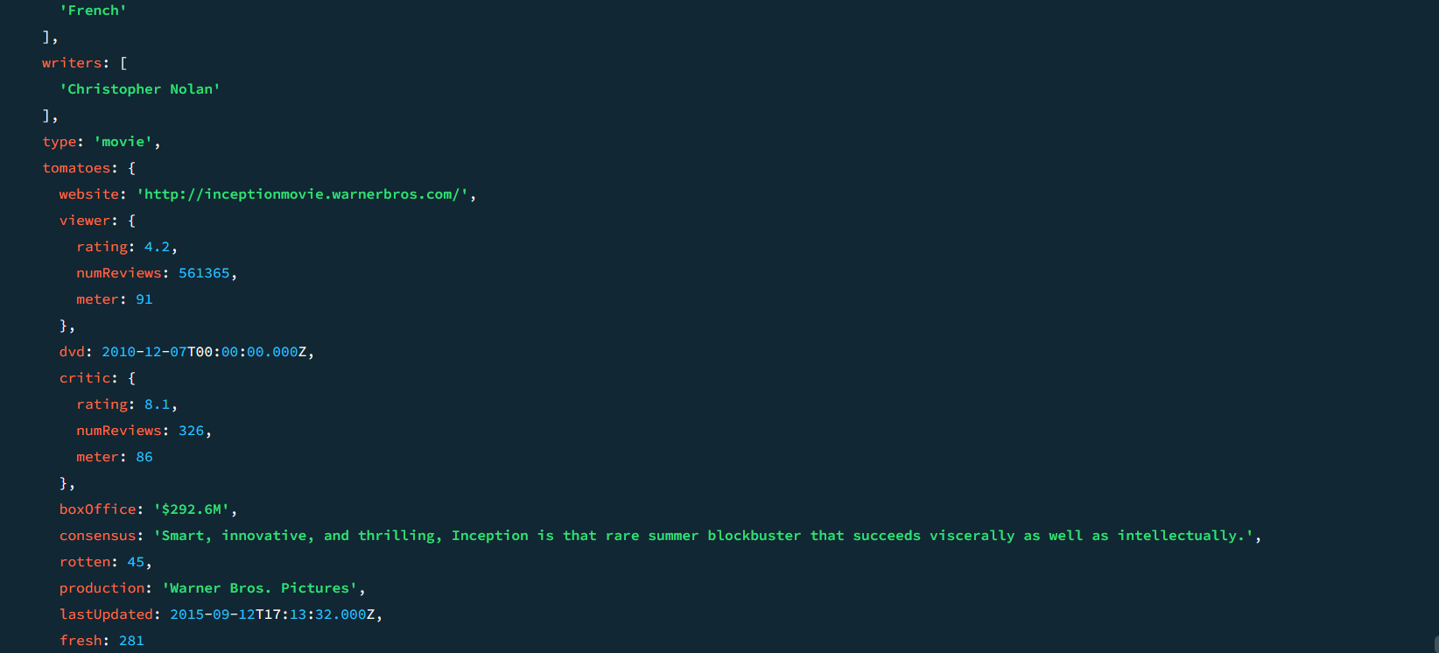
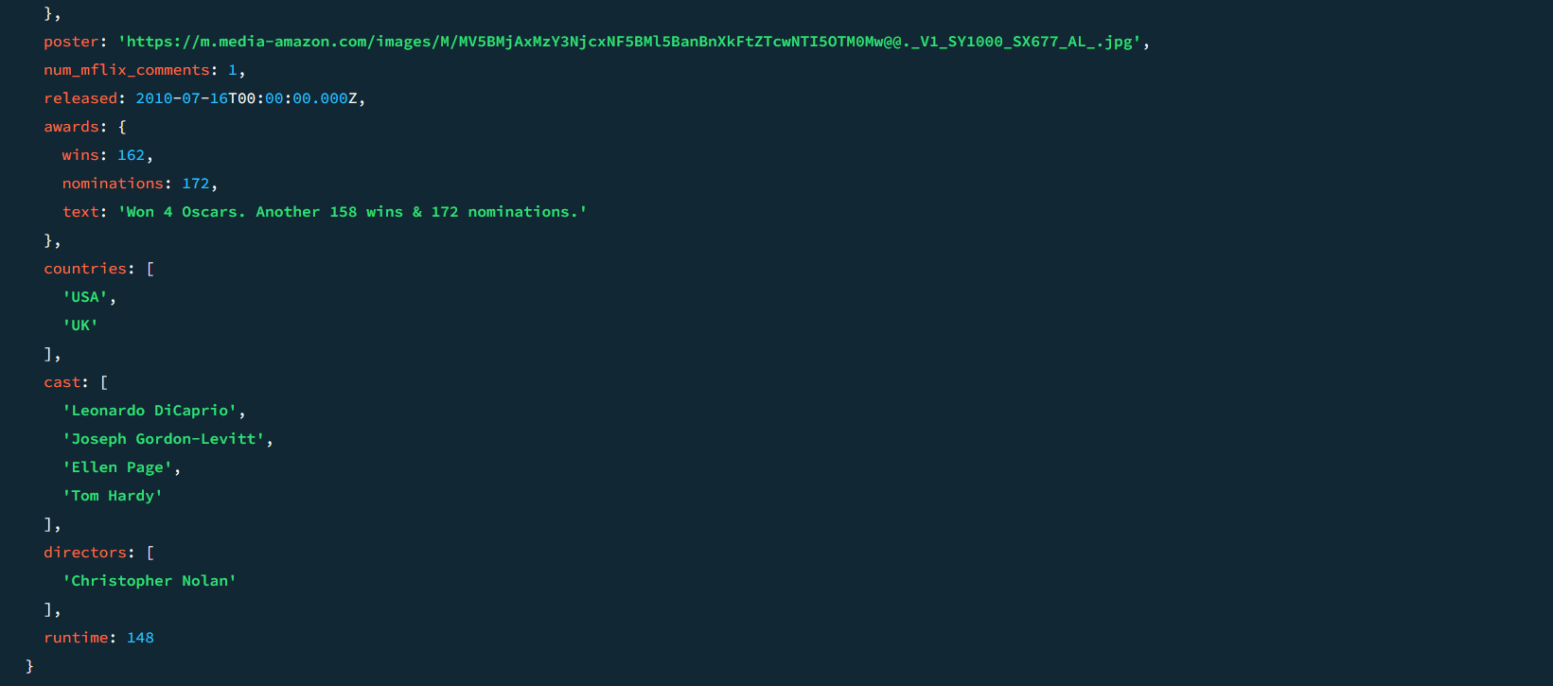




4️⃣ Identify Content for Specific Streaming Demographics
(Short, high-rated documentaries & biographies)
javascript
CopyEdit
db.movies.find({
$and: [
{ "genres": { $in: ["Documentary", "Biography"] } },
{ "runtime": { $lt: 100 } },
{ "imdb.rating": { $gt: 7 } }
]
})


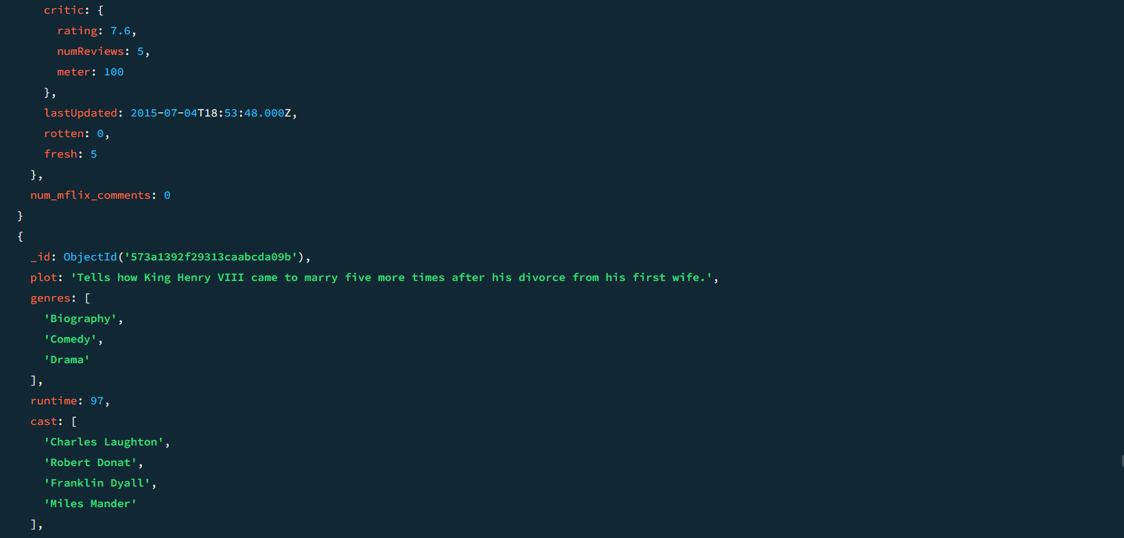

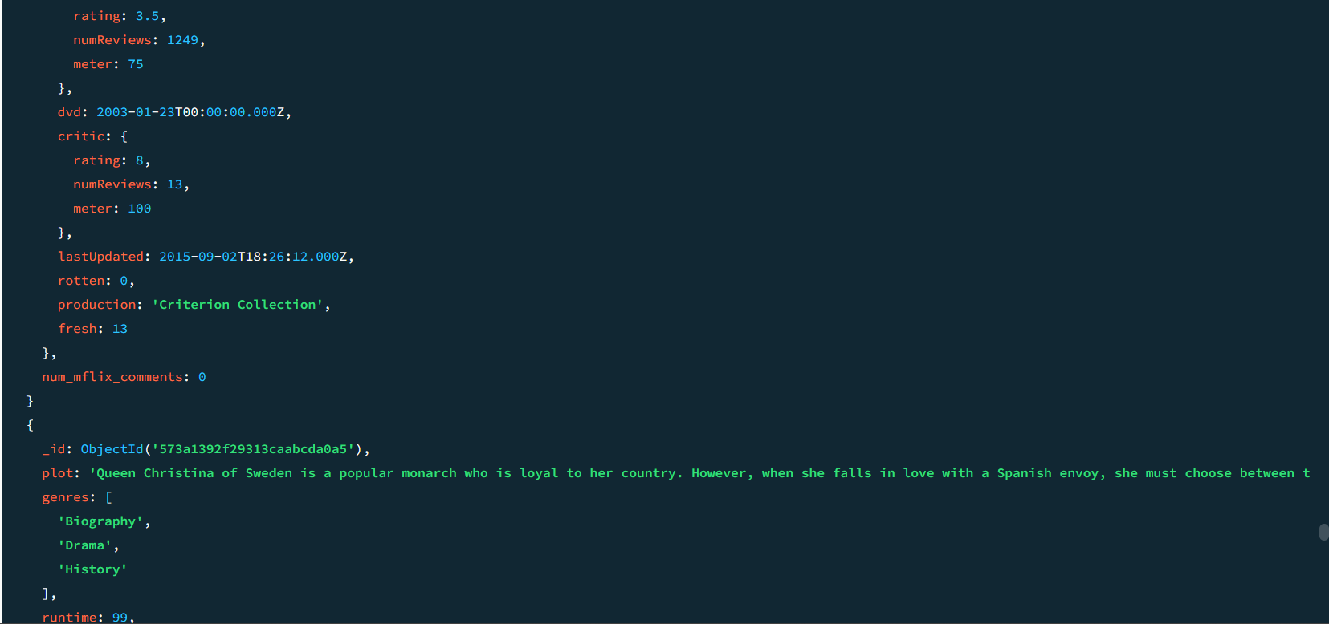
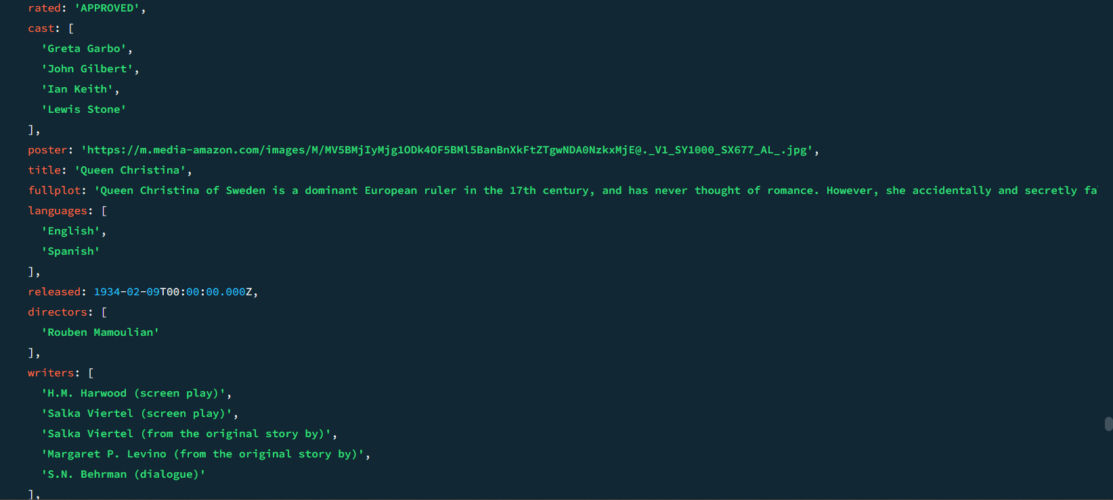


5️⃣ Find Genre-Blending Innovations with Audience Appeal
(Movies with 3+ genres and strong ratings)

db.movies.find({
$and: [
{ $expr: { $gte: [{ $size: "$genres" }, 3] } },
{ "imdb.rating": { $gt: 7.5 } }
]
})


6️⃣ Find Potential Licensing Targets for Game Adaptations
(Action, Fantasy, Sci-Fi films without existing games)

db.movies.find({
$and: [
{ "genres": { $in: ["Action", "Fantasy", "Sci-Fi"] } },
{ "imdb.rating": { $gt: 7 } },
{ "video_game": { $exists: false } }
]
})


7️⃣ Find Potential Documentary Series Expansions
(Highly rated, long documentaries)

db.movies.find({
$and: [
{ "genres": "Documentary" },
{ "imdb.rating": { $gt: 8 } },
{ "runtime": { $gt: 100 } }
]
})



8️⃣ Identify Unique Audience Segments via Niche Content
(Highly rated family-friendly animated musicals)

db.movies.find({
$and: [
{ "genres": { $in: ["Animation", "Musical"] } },
{ "rated": { $in: ["G", "PG"] } },
{ "imdb.rating": { $gt: 7.5 } }
]
})


